Excel Dashboard of Forecasted Key Income Statement Indicators
Accountants are often asked to forecast key income statement indicators. We will forecast revenue and net income numbers for the next 11 months and create an Excel Dashboard to facilitate management’s review of these key indicators.
- Open “Income Statement Balance Sheet Forecasting Raw Data.xls spreadsheet”. Go to “Income Statement Raw Data worksheet”,
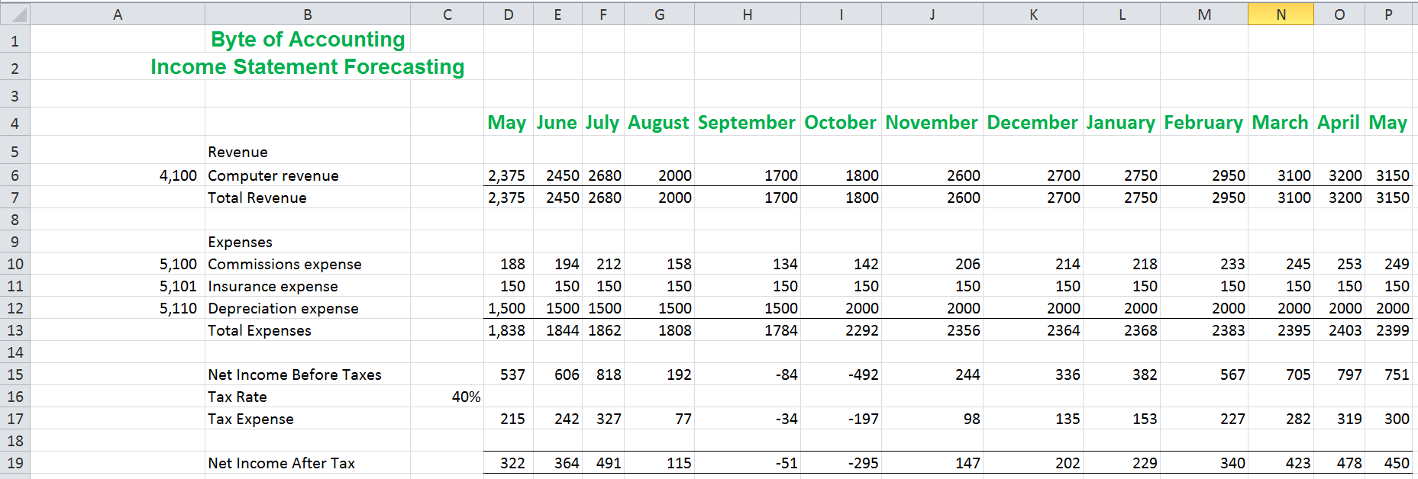
- Highlight D7:P7, D19:P19. Go to Insert → Charts →Column →2-D Column

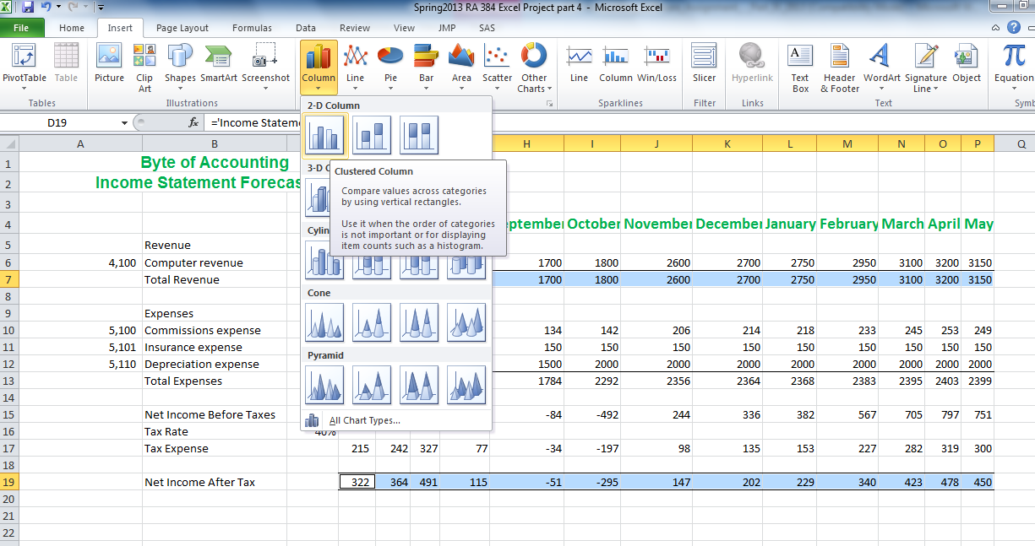
- Resize the chart area. Your screen should look like this:
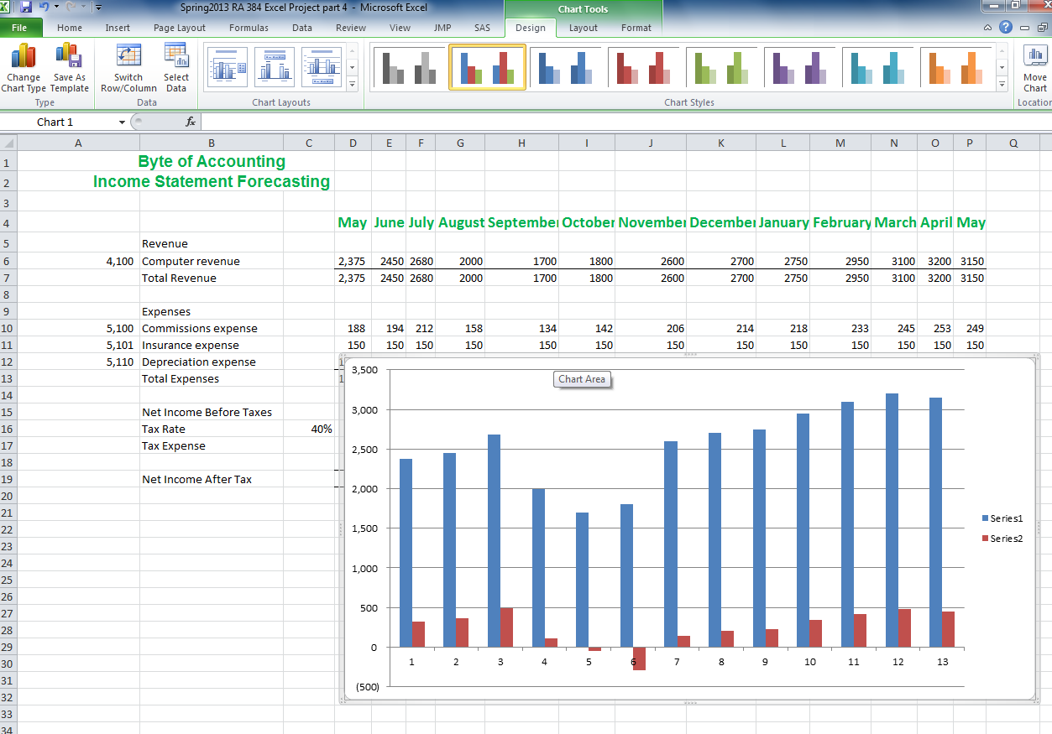
- Under Chart Tools tab, go to Design → Chart Layouts, select the one with chart title, X-axis title, Y-axis title and legend. In our example, we choose Layout 9.

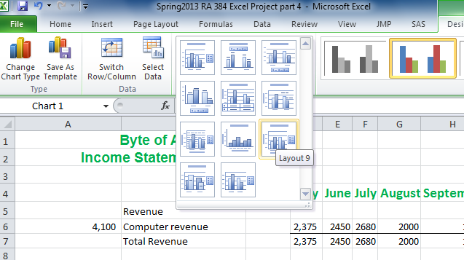
- Your Screen should look like this:
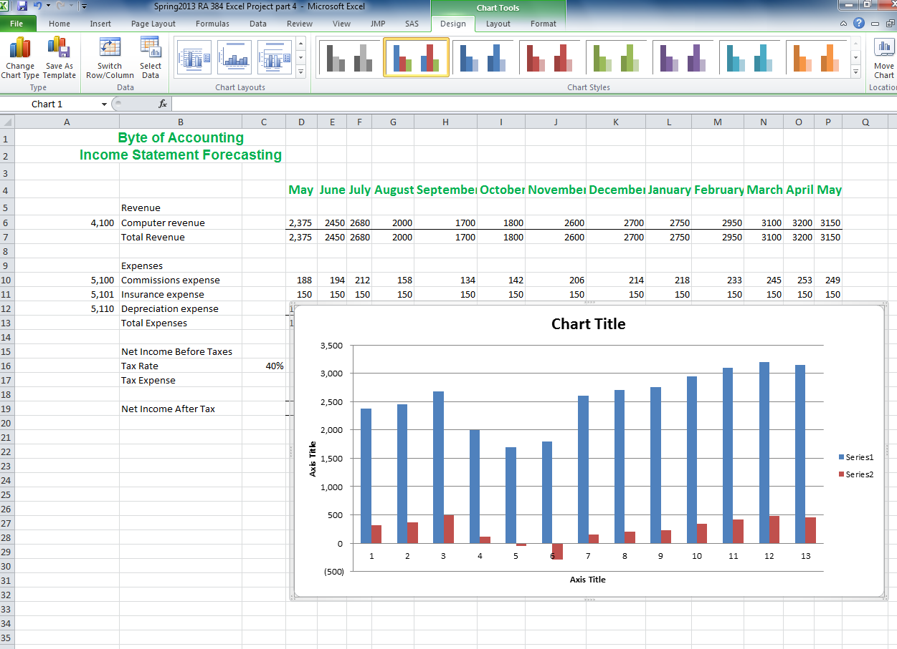
- In the Chart area, click “Chart Title”, type in “Byte of Accounting (Enter) Revenue and Net Income Forecasting”. Delete “X-Axis Title” and then then click “Y-Axis Title”, type in “U.S. Dollars”. Your Chart should look like this:

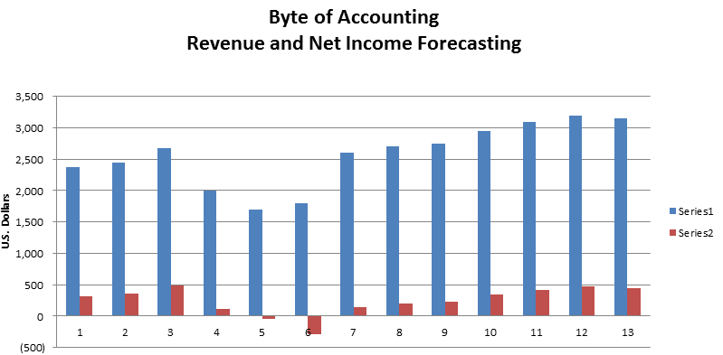
- Highlight the legend area “Series1 Series2”, right click and then select “Select Data…”.
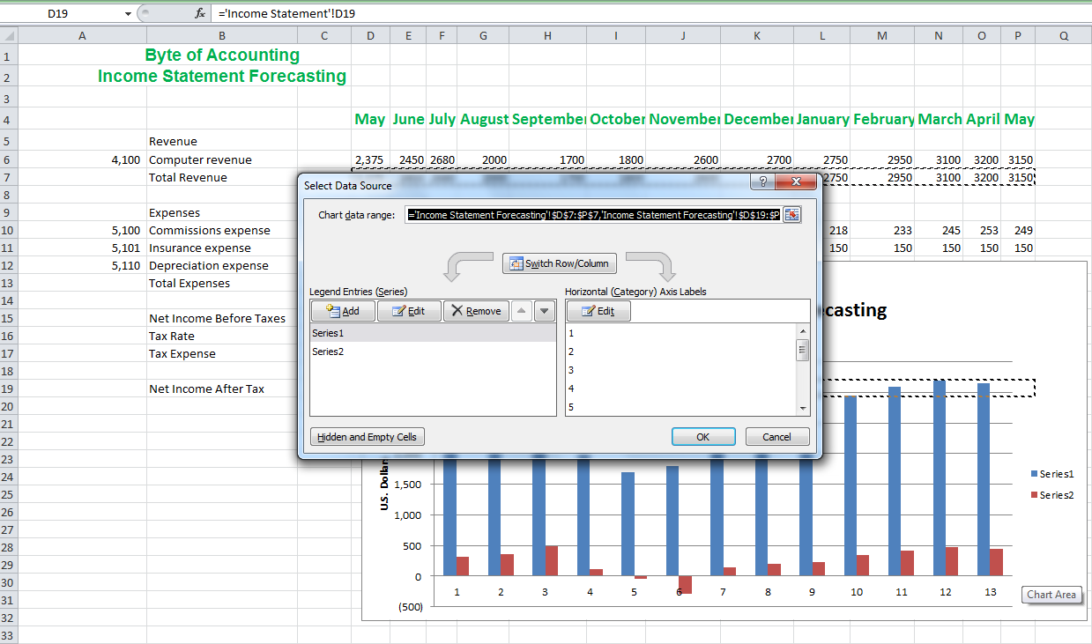
- In the Legend Entries (Series) area, select Series 1 and then click Edit. In the new “Edit Series window”, click cell B7 “Total Revenue” and then click OK.

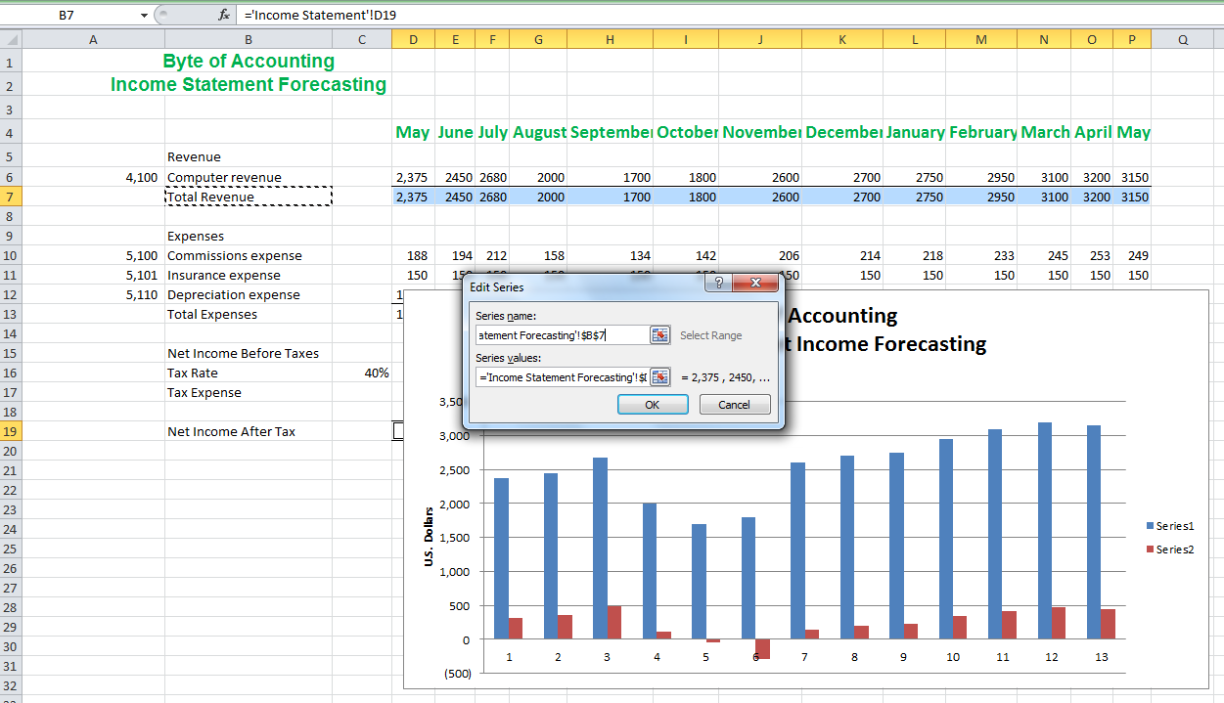
- Repeat the same steps to change Series 2 to show cell B19 “Net Income After Tax”. Your screen should look like this:
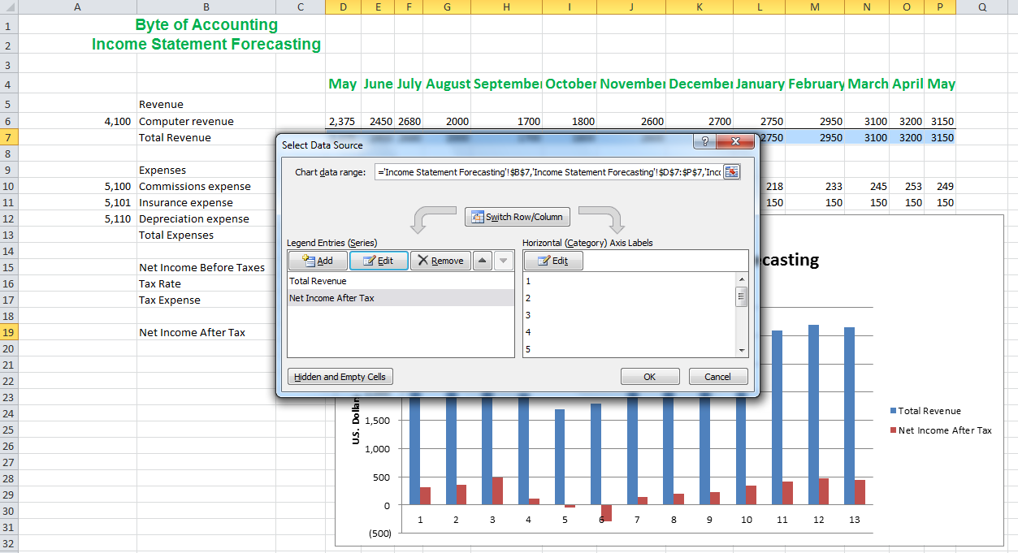
- In the Horizontal (Category) Axis Labels area, click Edit. In the Axis Labels window, select cell D4:P4 in the Axis label range and then click OK.

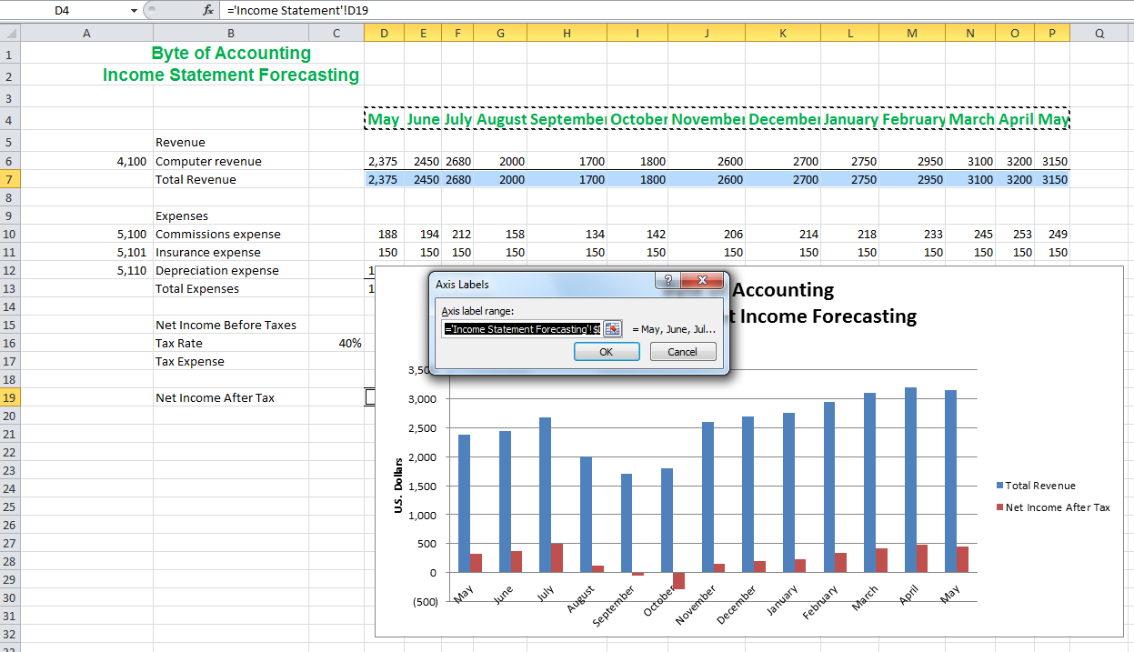
- Your graph should look like this:
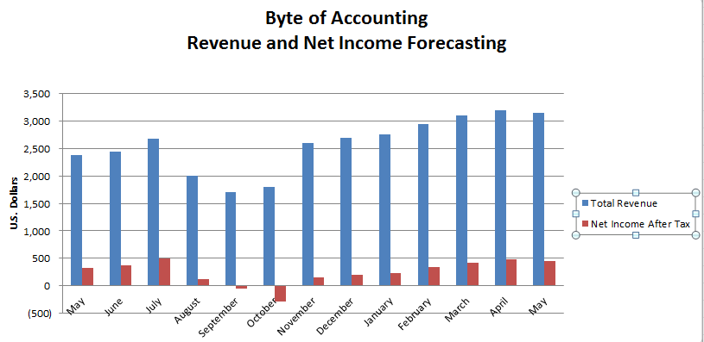
- Select any blue bar in the graph, right click and choose “Change Series Chart Type…”
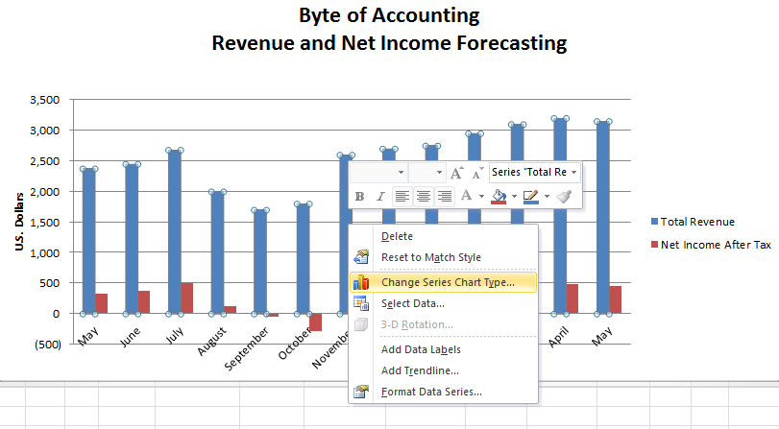

- In the Change Chart Type window, select “Line” → “Line with Markers” and then click OK.
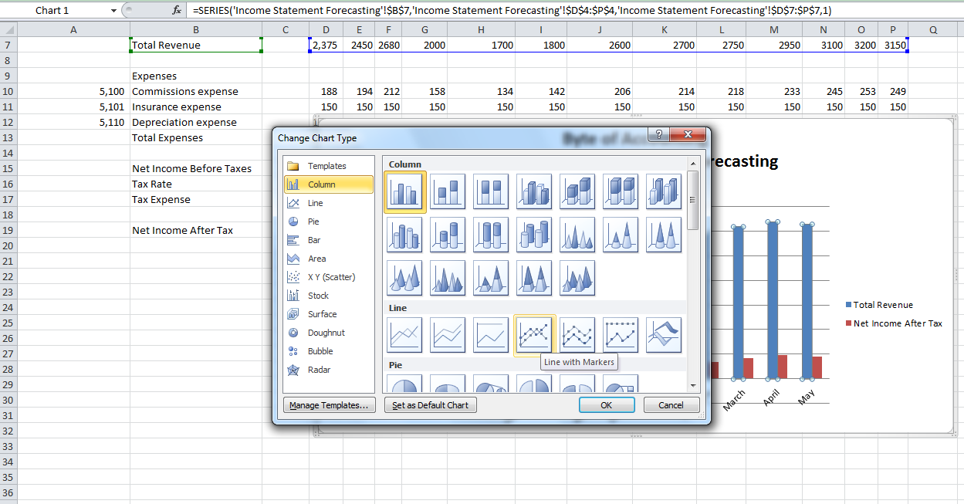
- Your chart should look like this:

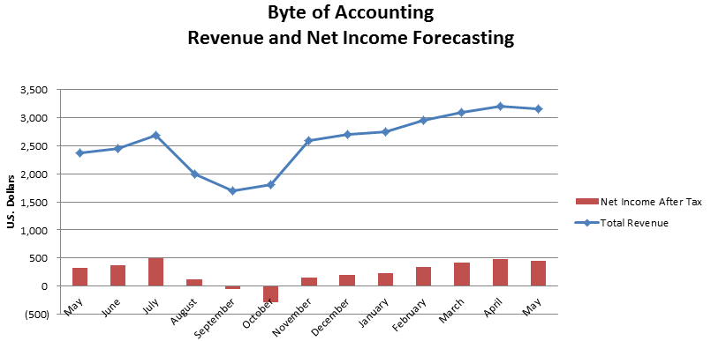
- To add label to both “Net Income After Tax” and “Total Revenue”, select any bar and right click, then select “Add Data Label”. Repeat the same step for the Line. Your graph should look like this:
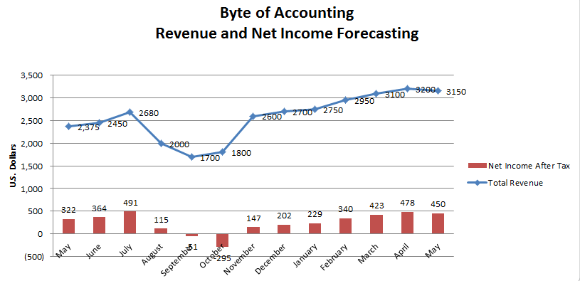
- Create a new workbook after “Income Statement Forecasting” and name the new workbook as “Income Statement Dashboard.”

- In the Income Statement Forecasting workbook, cut the graph and paste it into cell A1 in “Income Statement Dashboard”. Your screen should look like this:

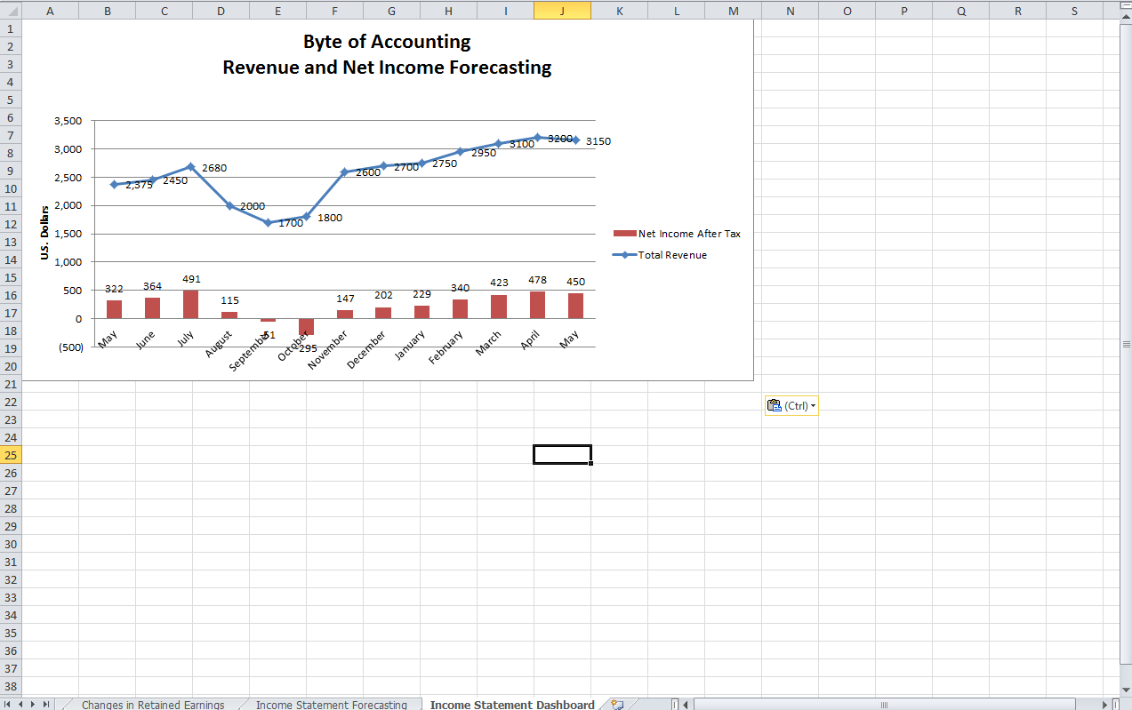
Instructions to Create Data Visualization with Tableau
Import Data File
Click Connect to Data link (See Figure 4-1) on upper left-hand side of the task pane to upload your data source.
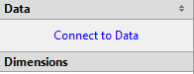
Figure 4-1 Connect to Data Link

Choose type of data source file and click next (See Figure 4-2).
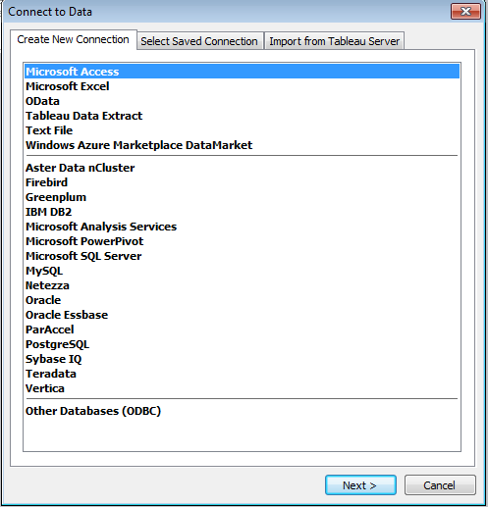
Figure 4-2 Data Source File Type

Browse for desired data file. Select Orders worksheet to analyze. Check box “Yes, the first row has the field names in it” and name connection. Select Connect Live to import data (See Figure 4-3).
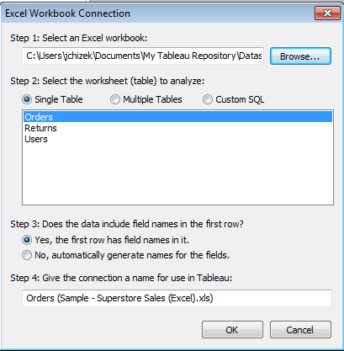
Figure 4-3 Import File

Move Information Into Work Areas
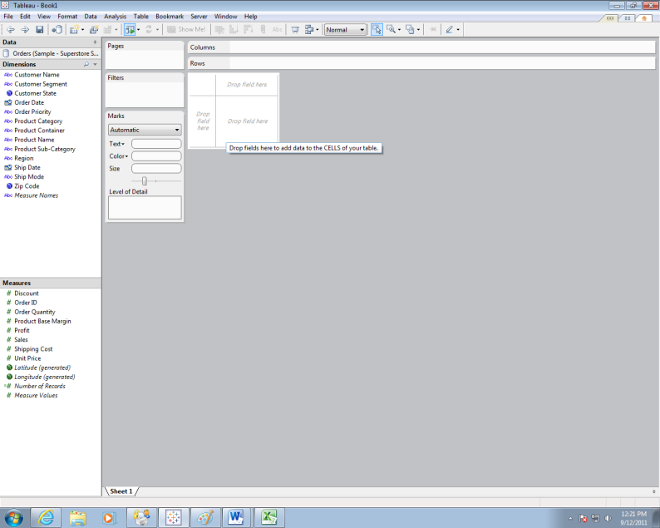
Figure 4-4 Work Area to Create Charts

Figure 4-4 shows work area to create charts. To create chart, drag dimension/measure to “Drop Field Here” table or to Column/Row area above table. To create bar chart showing total profits for each product category, drag Product Category to Column area and Profit to row area (See Figure 4-5).
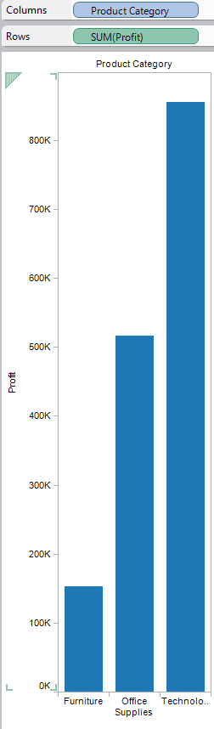
Figure 4-5 Profit by Product Category Bar Chart

Change Colors/Formatting
To add data labels, select Label heading, and then check box next to Show Mark Labels. Each bar is now labeled.
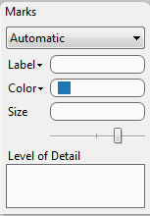
Figure 4-6: Marks Task Bar

Using Marks task bar (See Figure 4-6), click blue box next to word Color and select color to shade bars.

We can also color by product category. Drag Product Category from dimension pane to Color bubble. Three bars are now uniquely colored and your graph should look like this (See Figure 4-7).
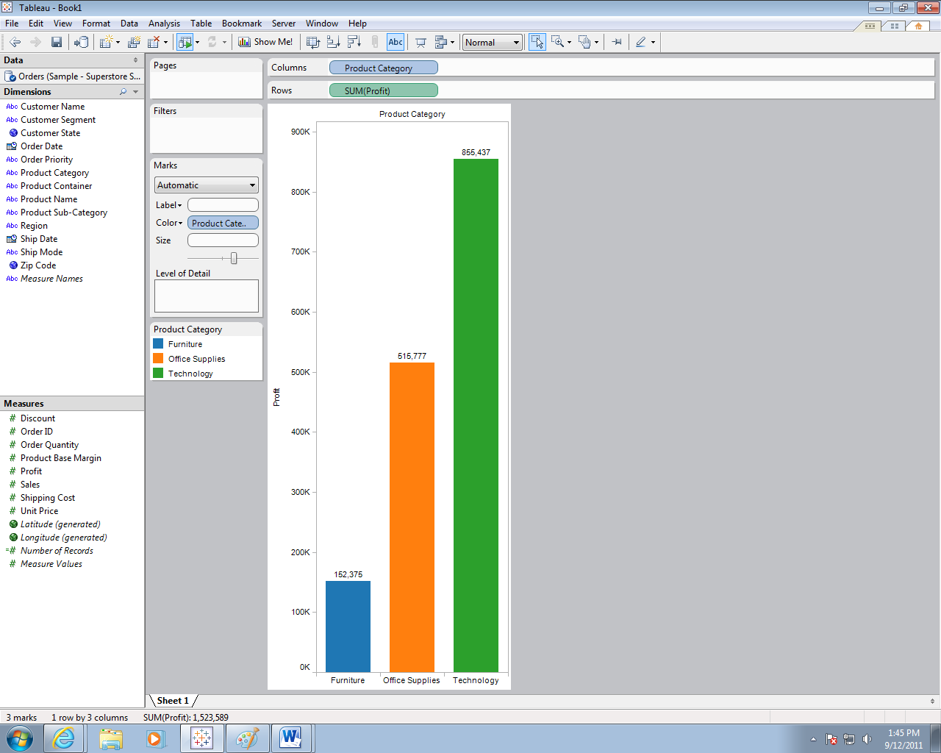
Figure 4-7 Profit by Product Category Bar Chart with Colors Changed

To add title, click Edit on toolbar and select Title. A text box appears. Name graph “Figure 1: Profit by Product.”

Filter Data and Create Drill Down Data
To filter data, drag filter dimension to filter area. For our example, drag Order Date to Filter task pane. This menu should appear (See Figure 4-8):
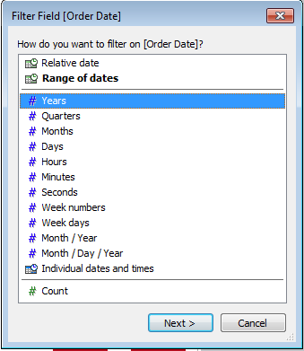
Figure 4-8 Filter Field Menu

Select Years and click Next. Next, you can select years individually. Check 2012 and 2013 and click OK. Your screen should look like this (See Figure 4-9):
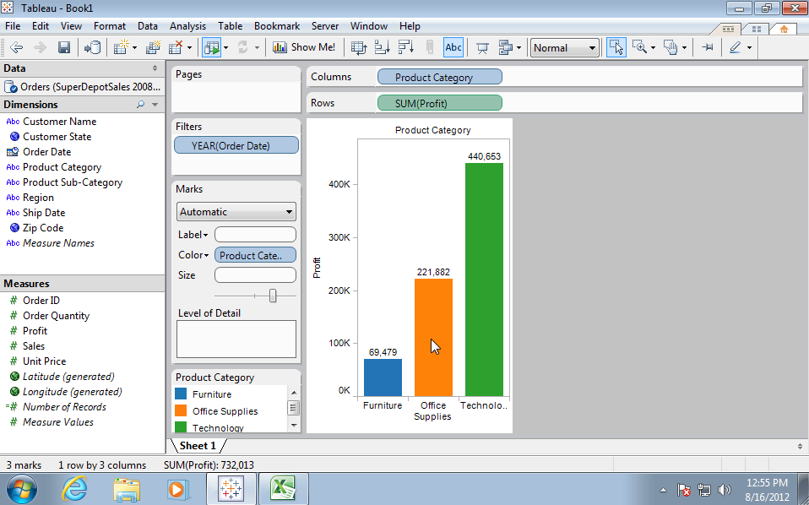
Figure 4-9 Profit by Product Category for 2012 and 2013

To add two more filters, drag Region dimension to Filters area, select Central in pop out window, click OK. Drag Product Category dimension to Filter area, select Furniture and Technology, then click OK. Your screen should look like this (See Figure 4-10):
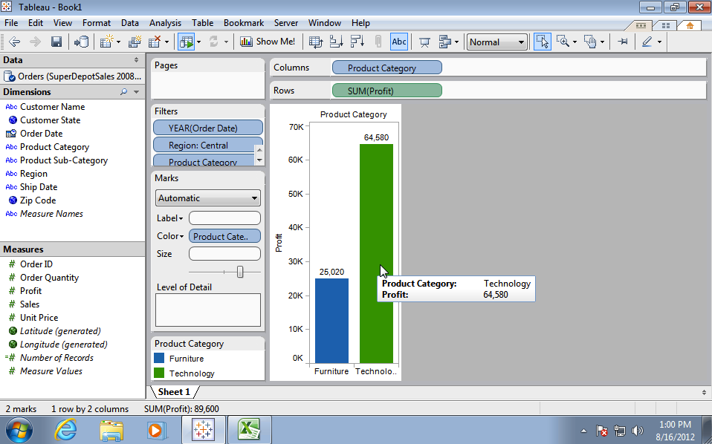
Figure 4-10 Profit by Product Category for 2012 and 2013 for Furniture and Technology

Create Drill Down Data
Start from Figure 4-11 to drill down to show yearly profit of Office Supplies.
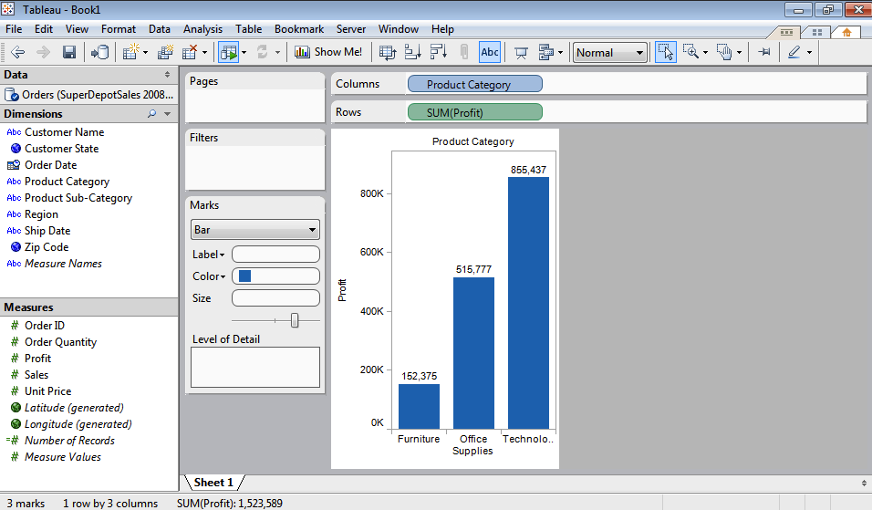
Figure 4-11 Illustration – Drill Down Screen

To drill down to show yearly profit, drag Year (Order Date) to Level of Detail Area. Yearly profit shows up on each bar. To make graph more appealing, color bars by dragging Order Date dimension to Color (See Figure 4-12).
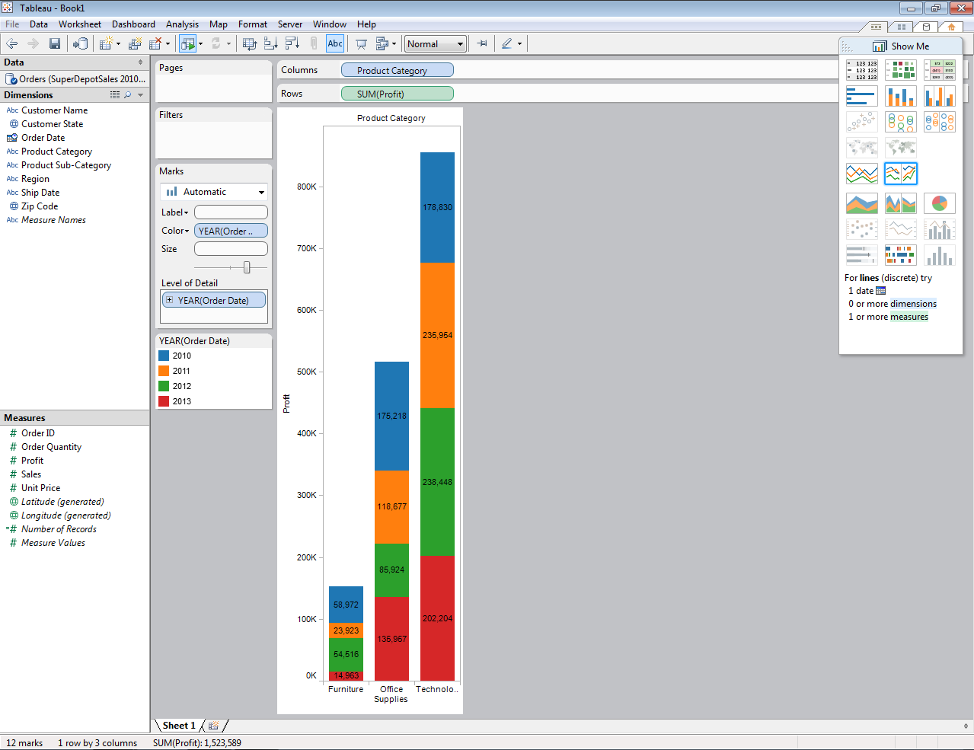
Figure 4-12 Illustration – Using Bar Chart Color by Order Date Dimension

To drill down to show yearly profit of Office Supplies, drag Product Category to Filters area, select Office Supplies, and then click OK. Drag Order date dimension (Year(Order Date) ) to Columns area, Drag Product Category dimension to Rows area (See Figure 4-13).
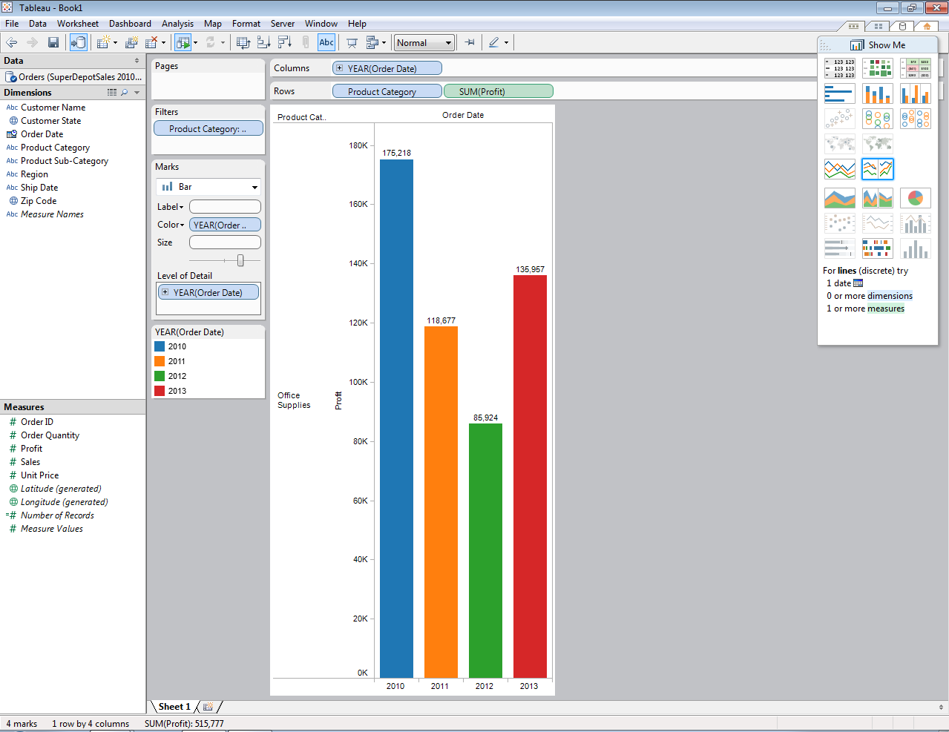
Figure 4-13 Illustration – Drill Down for Yearly Profit of Office Supplies

To drill down further to show regional profit, simply drag region to Level of Detail area, regional profit shown up on each bar. To make regional details more obvious, we can color bars by region. Place curser near each regional profit, regional profit details are shown (See Figure 4-13).
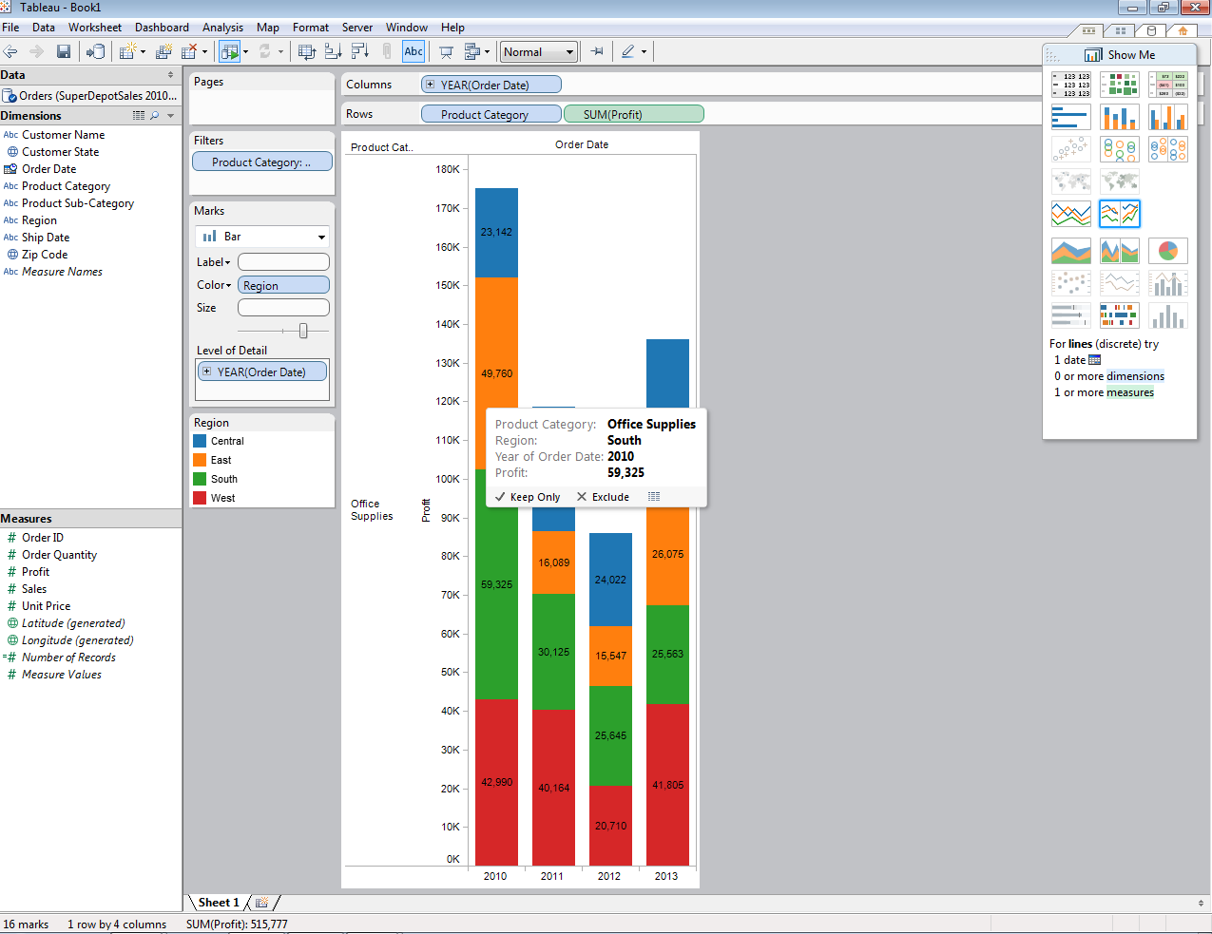
Figure 4-13 Illustration – Drill Down Office Supplies Profit by Region

We can also add one more Filter (Year(Order Date), and manipulate Columns and Rows to show clear drilled down chart showing only 2011’s regional office supply profit chart (See Figure 4-14).
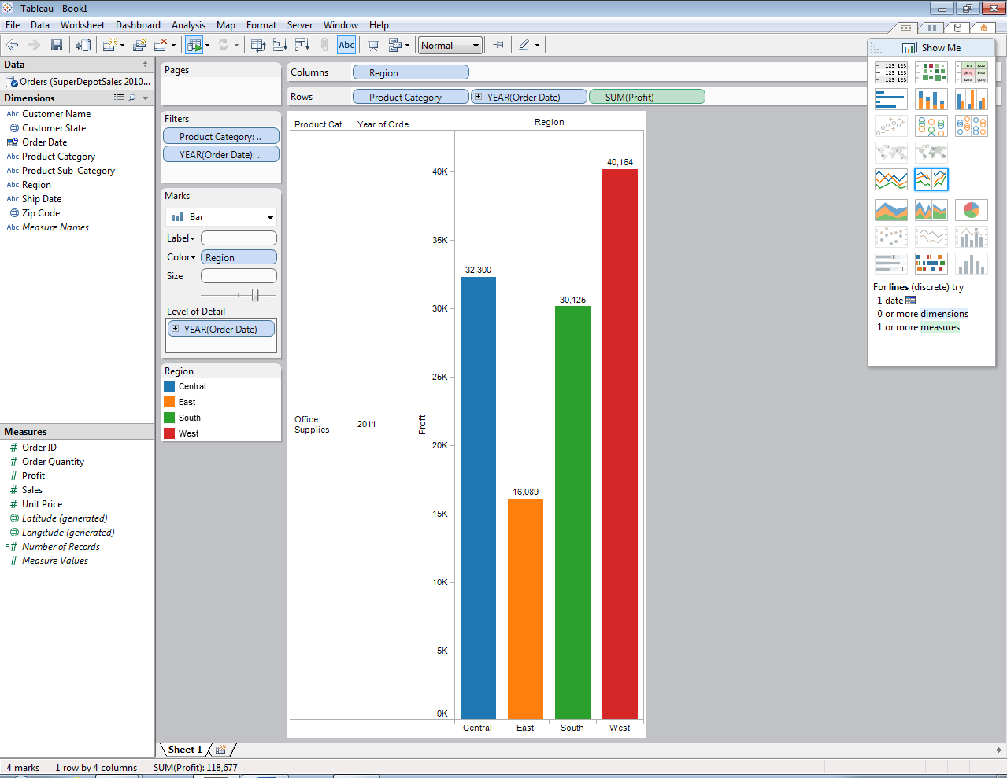
Figure 4-14 Illustration – Drill Down for 2011 Office Supply Profit by Region

Save File
To insert new page to file, click Edit on toolbar and New Worksheet.
To save your data, select File → Save As. The next time you open Tableau your project will appear on Recently Opened list.

